DBMS ASSIGNMENT-7

Praneesh R V

CB.SC.U4CYS23036

Scenario 1,

COURSES Table

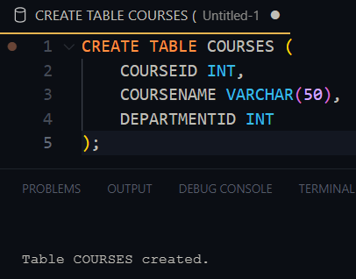

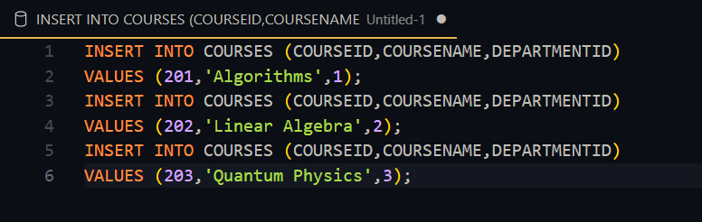

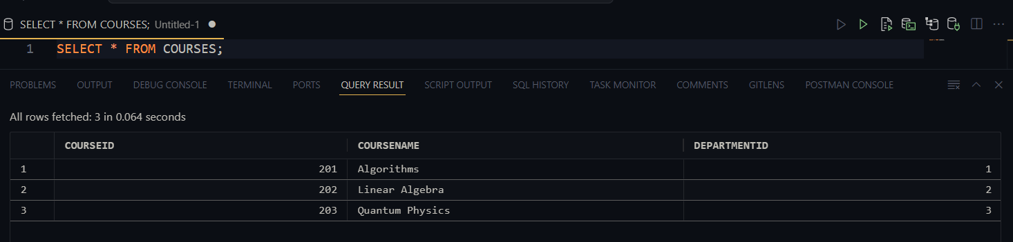

DEPARTMENTS Table

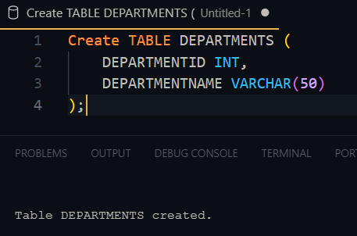

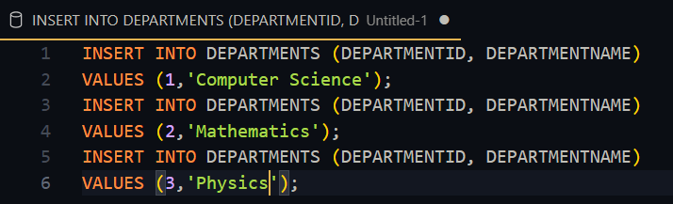

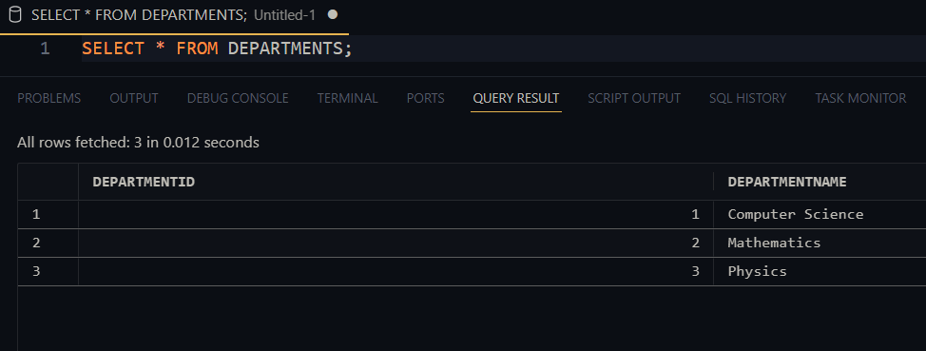

ENROLLMENTS Table

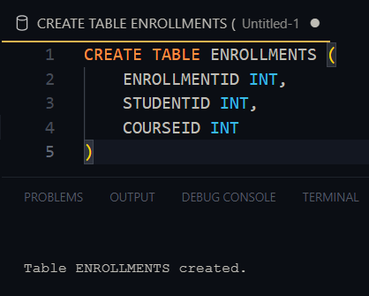

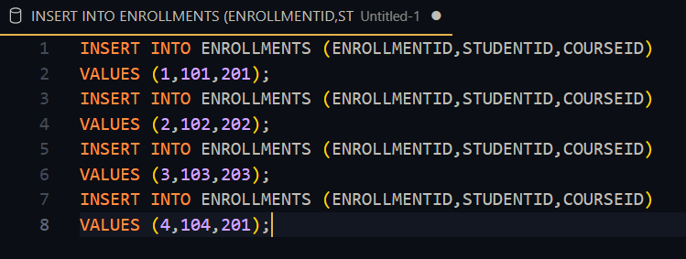

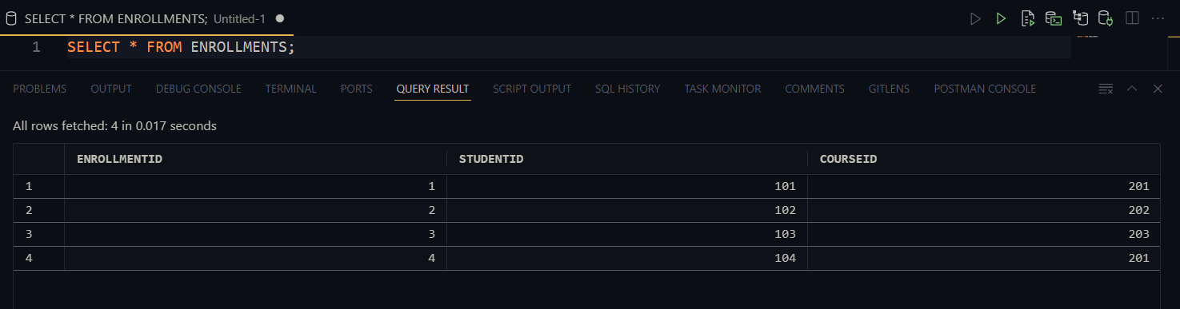

Students table

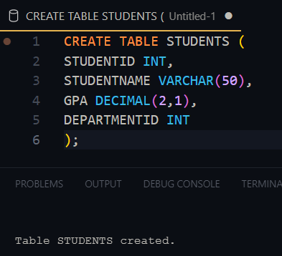

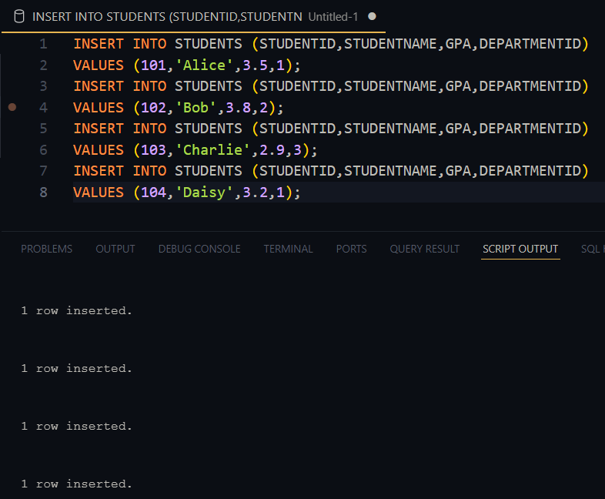

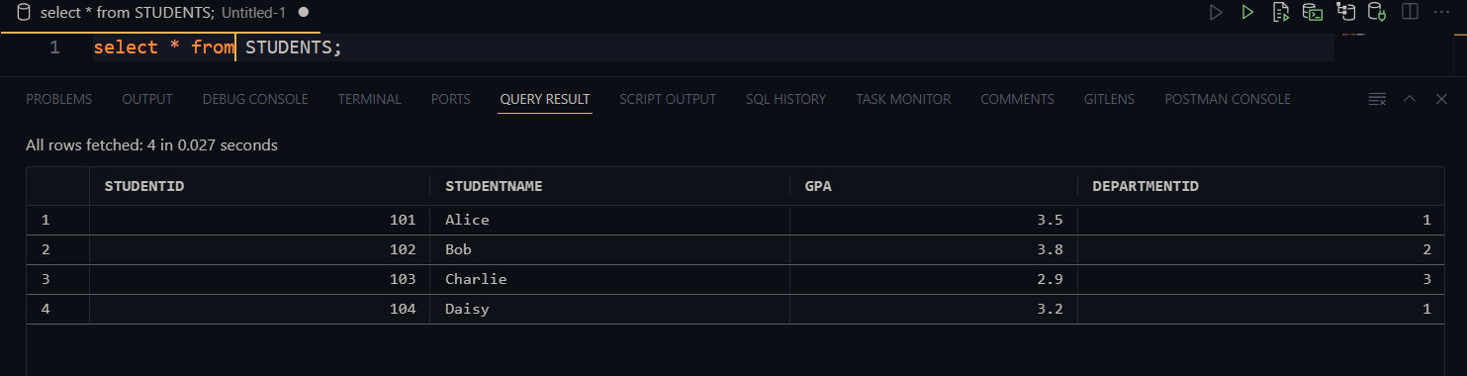

Qn 1, *List the names of students along with the courses they are enrolled in using a LEFT JOIN.*

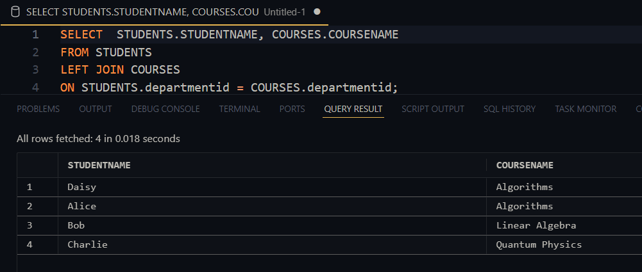

Qn2, Show all departments that have no students.

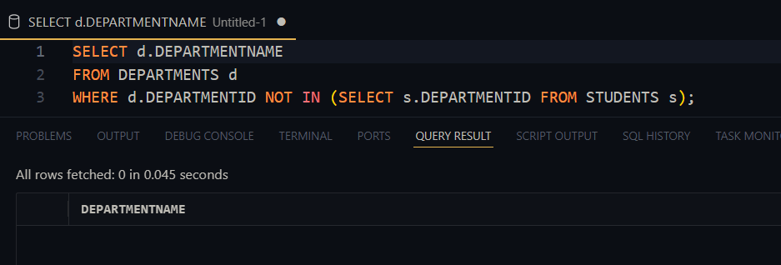

Qn3, Retrieve students enrolled in the 'Algorithms' course using a subquery with a join.

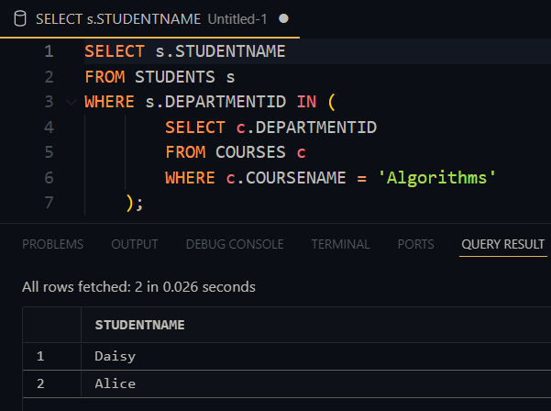

Qn 4, Find courses where all enrolled students have a GPA higher than 3.0.

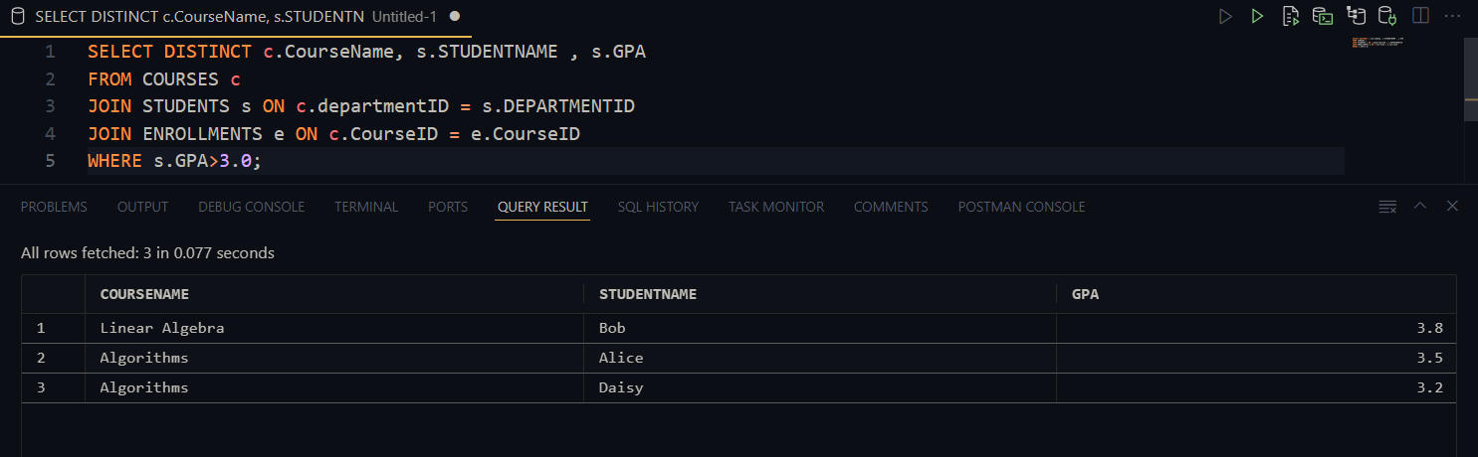

Qn 5, Find departments with fewer than 2 students enrolled.

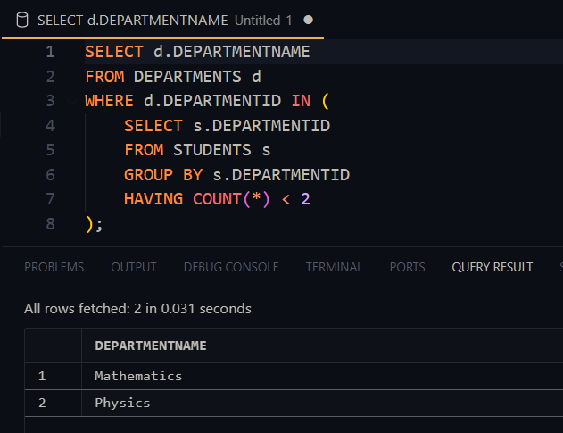

VIEWS

COURSEENROLLMENTCOUNT

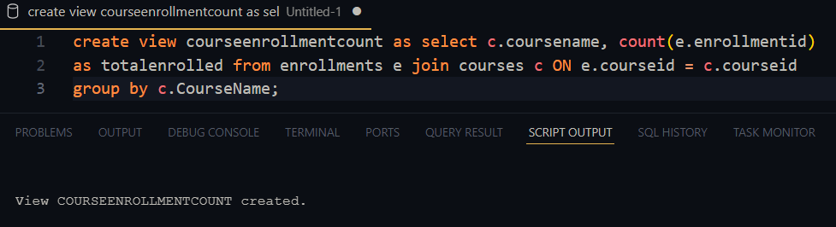

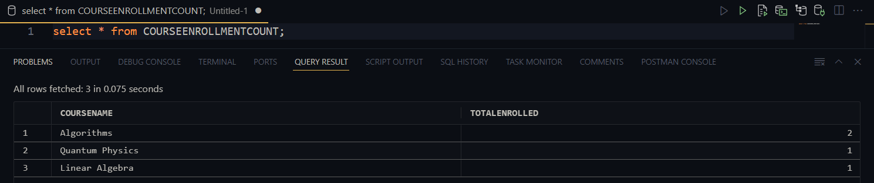

STUDENTCOURSES

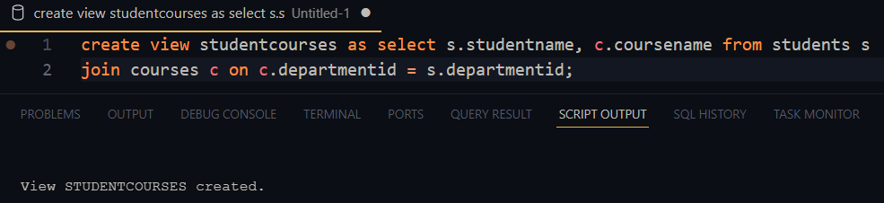

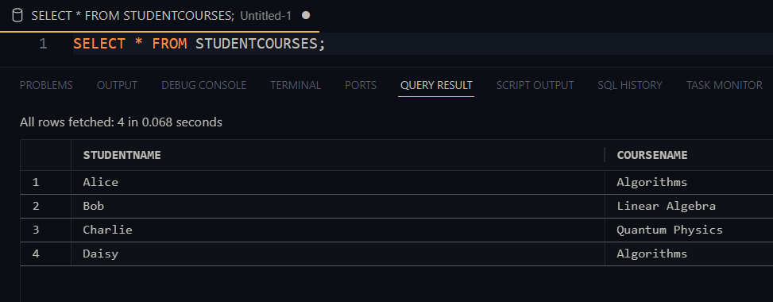

STUDENTGPABYDEPT

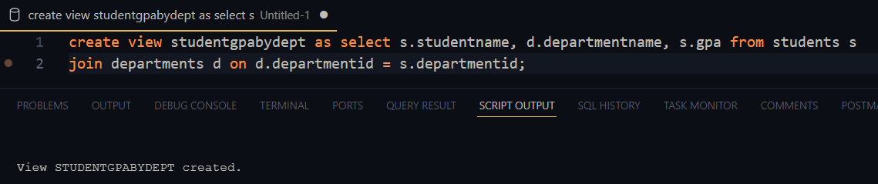

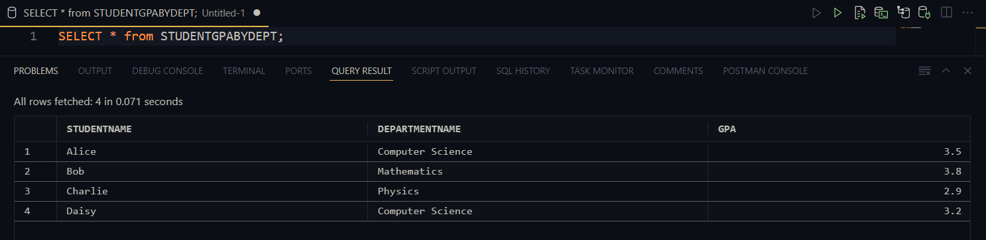

Qns

Qn6,

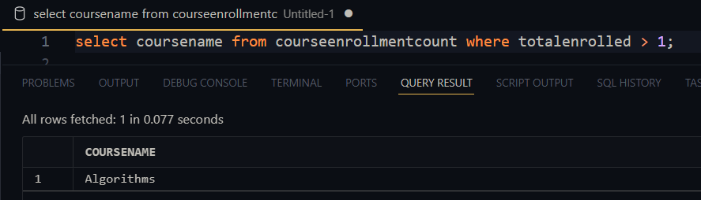

Qn7,

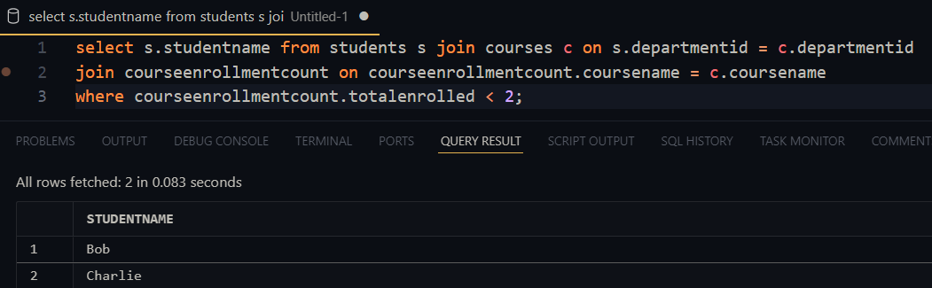

Qn 8,

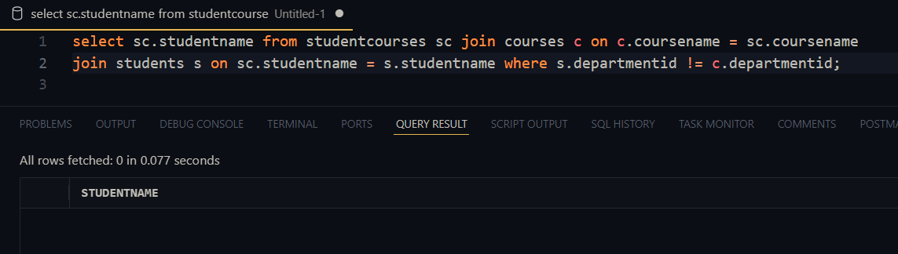

Qn 9,

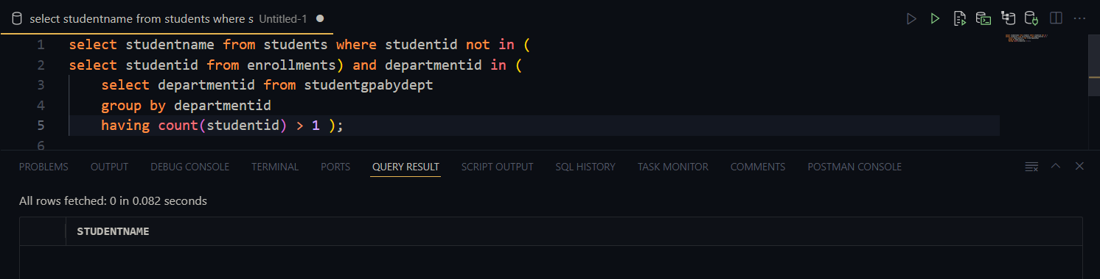

Qn 10,

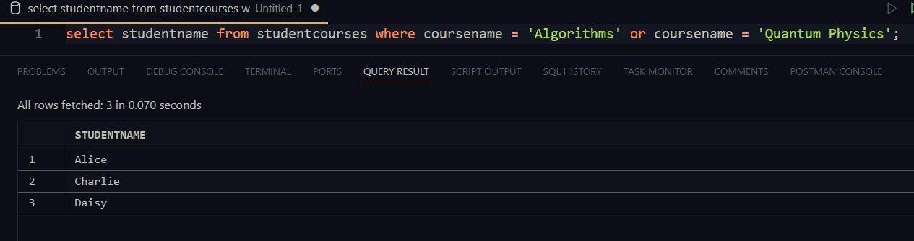

SCENARIO 2

CUSTOMERS TABLE

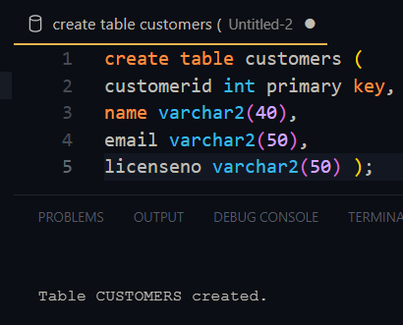

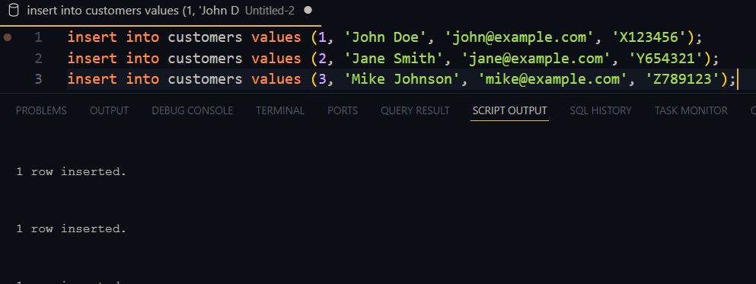

LOCATIONS TABLE

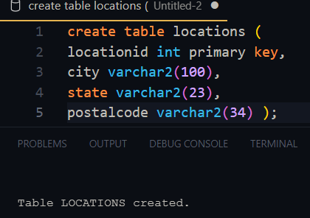

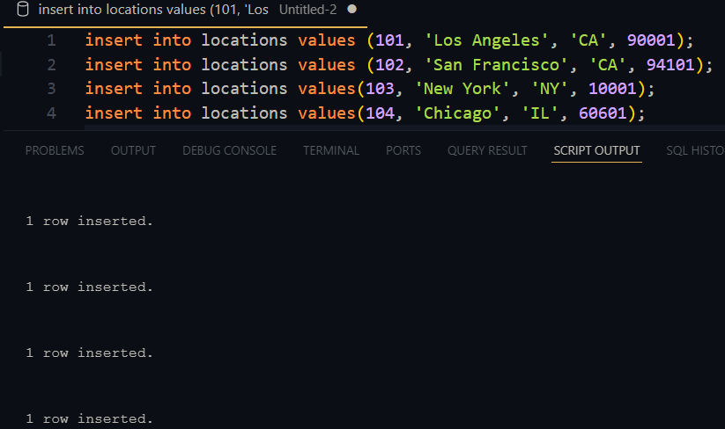

RENTALS TABLE

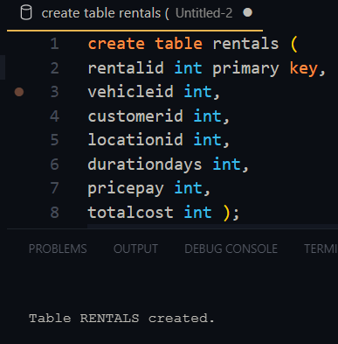

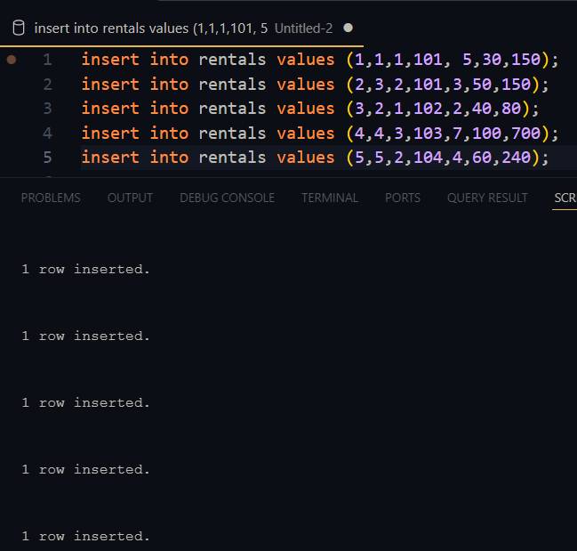

VEHICLES TABLE

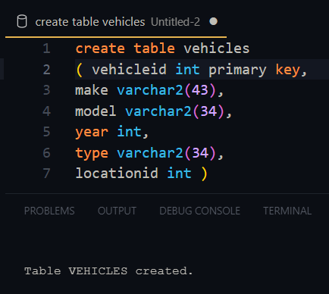

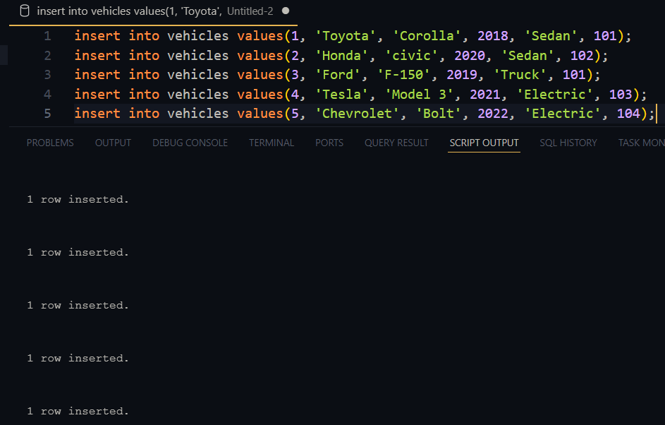

Qn1,

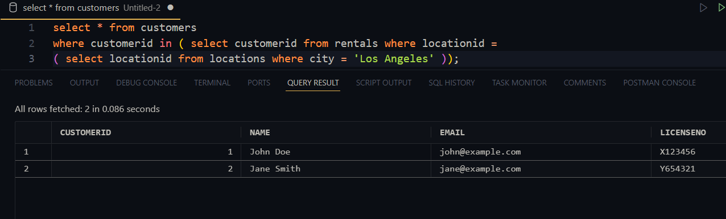

Qn2,

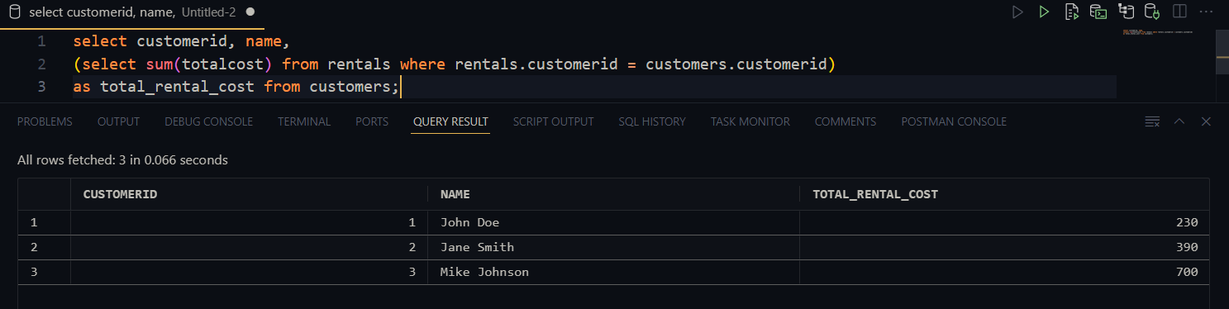

Qn3,

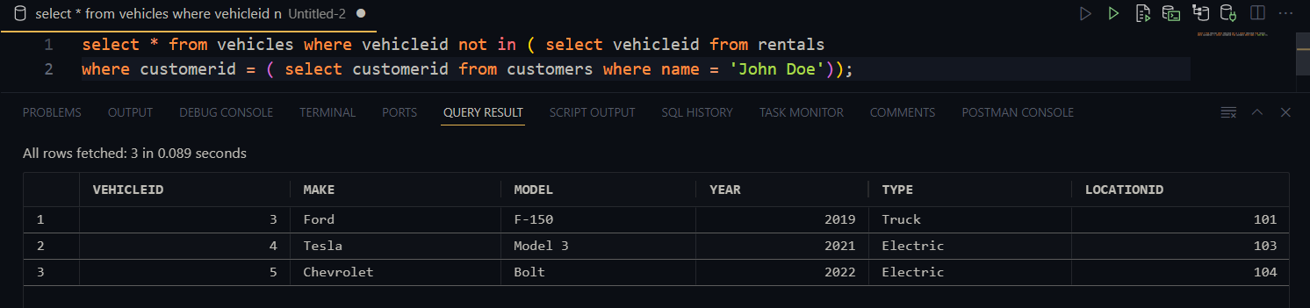

Qn 4,

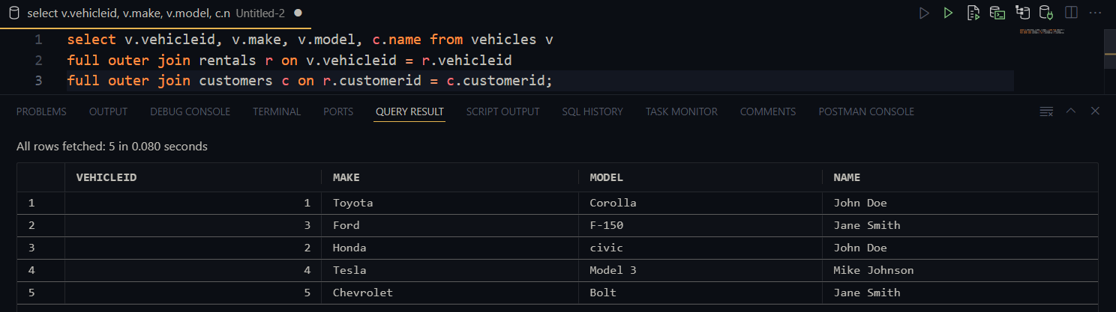

Qn 5,

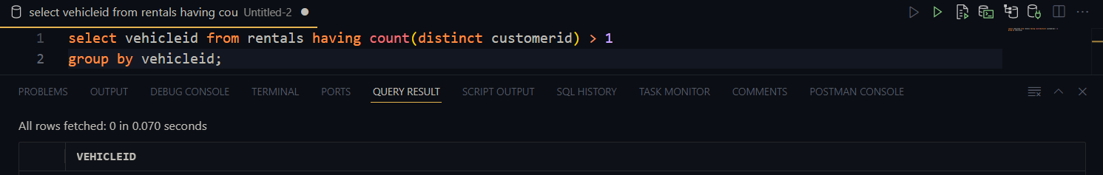

Qn6,

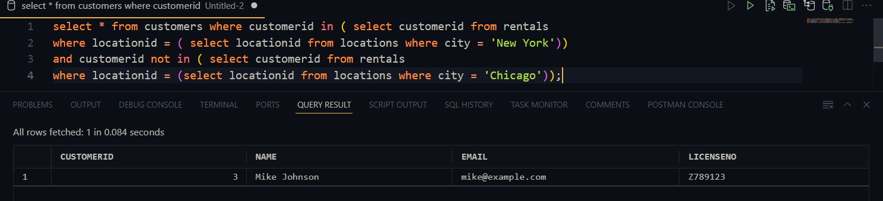

VIEWS

CUSTOMERRENTALHISTORY

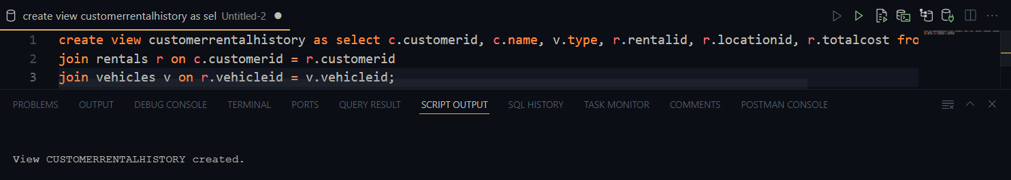

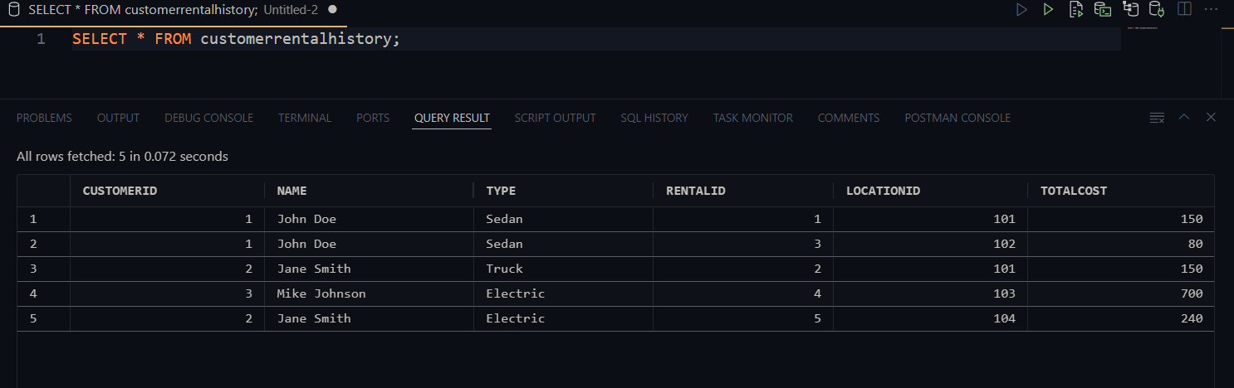

HIGHREVENUECUSTOMERS

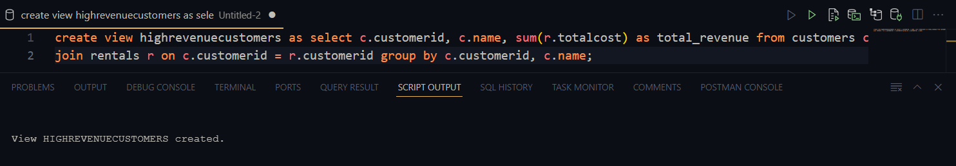

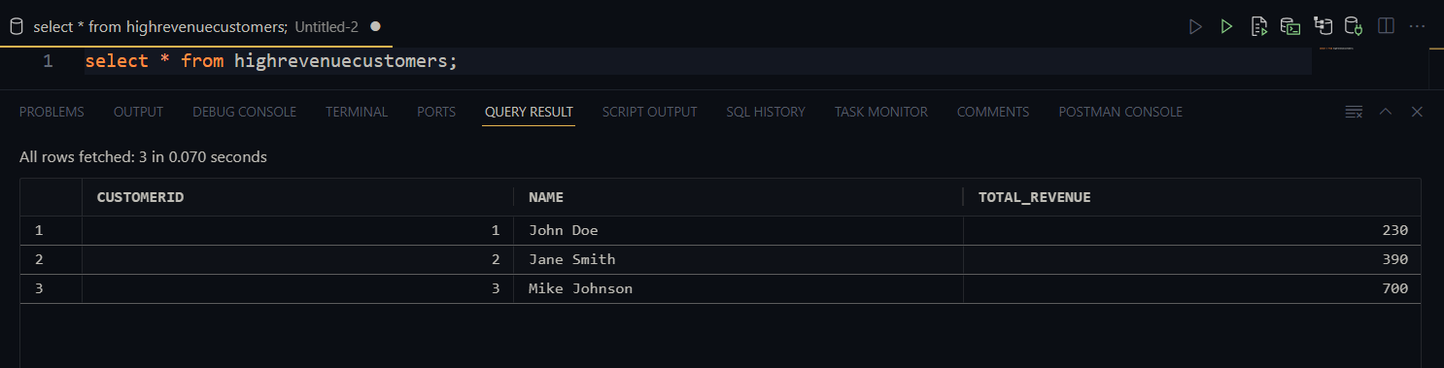

VEHICLERENTALDETAILS

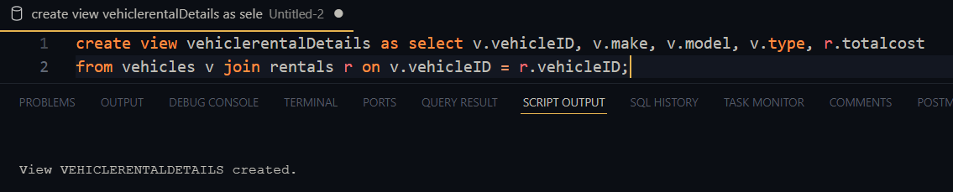

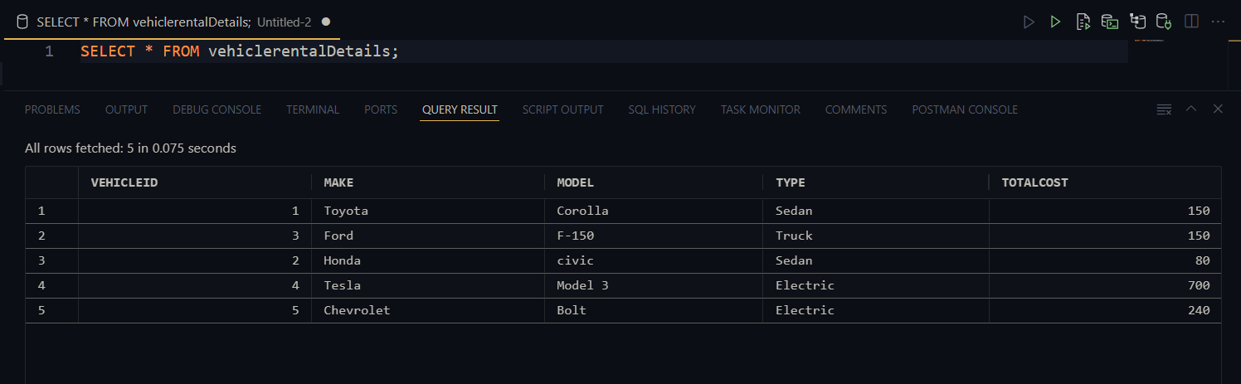

Qn7,

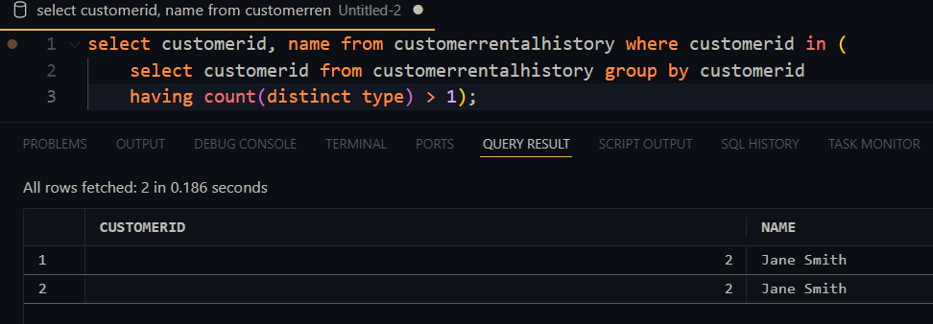

Qn 8,

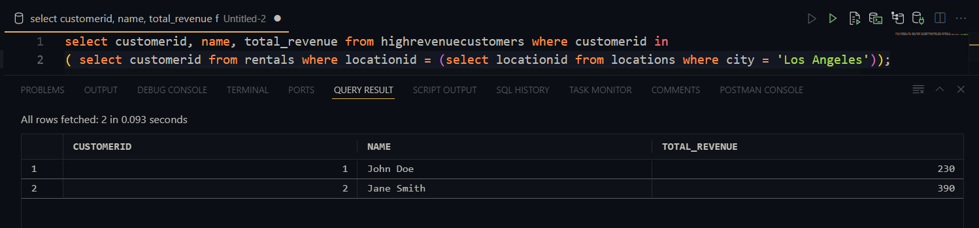

Qn 9,

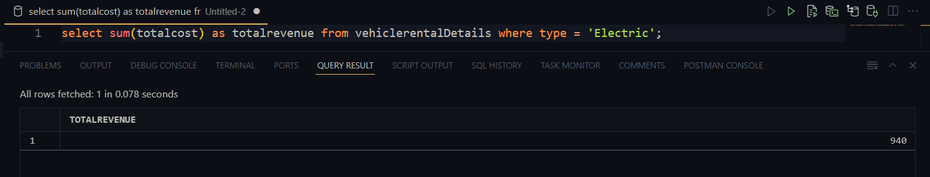

Qn 10,

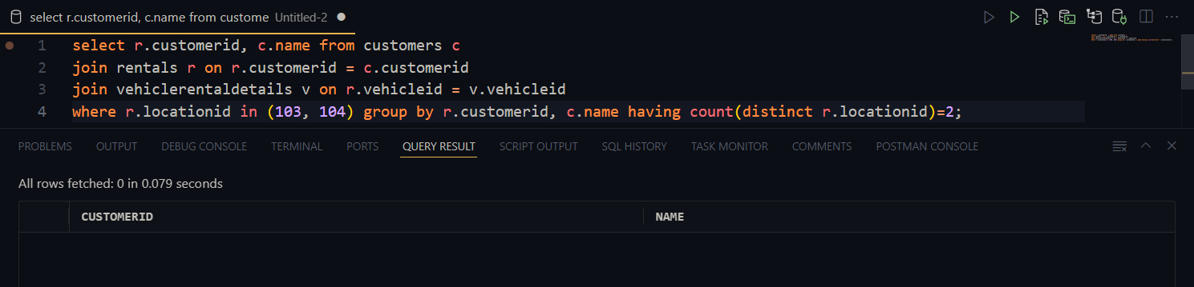

SCENARIO 3

AUTHORS Table

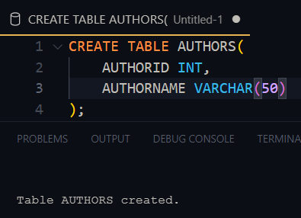

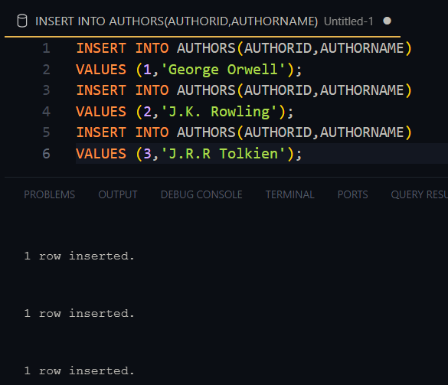

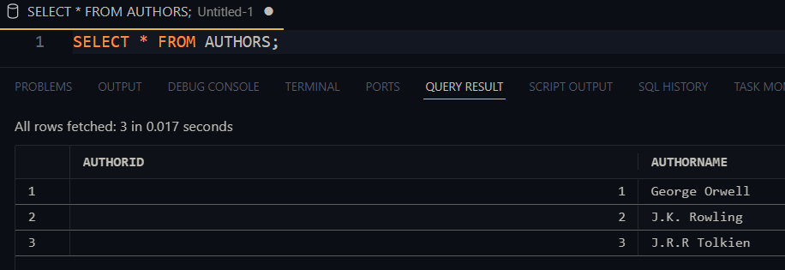

BOOKS Table

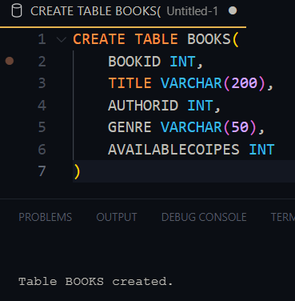

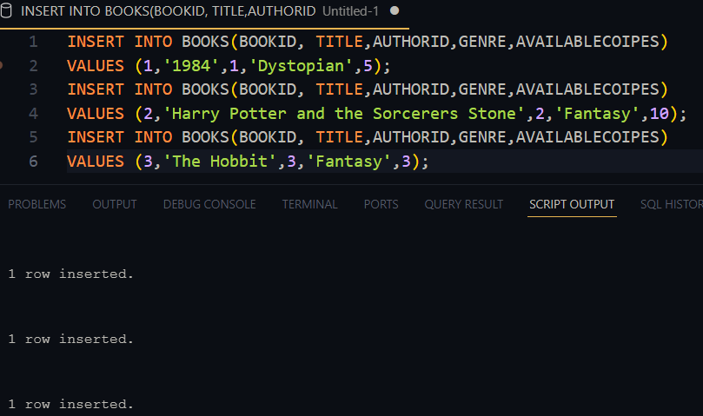

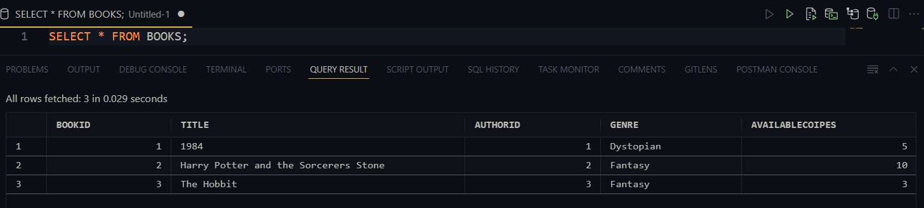

LOANS Table

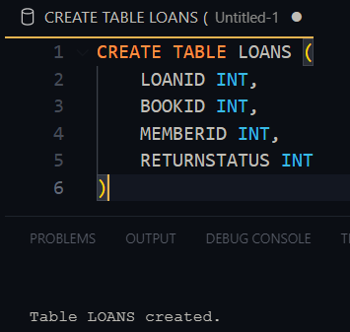

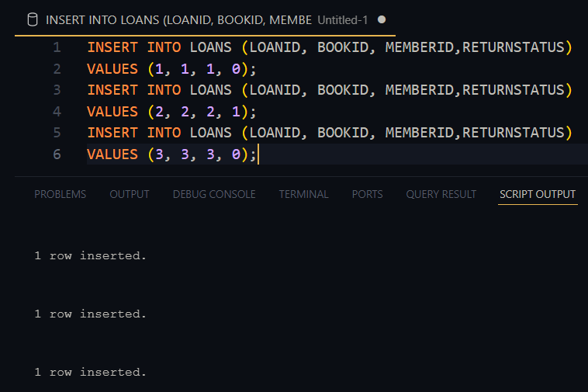

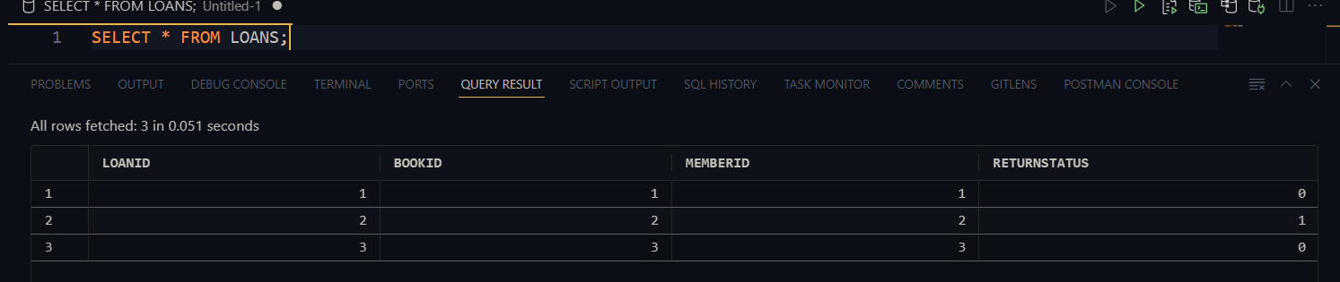

MEMBERS Table

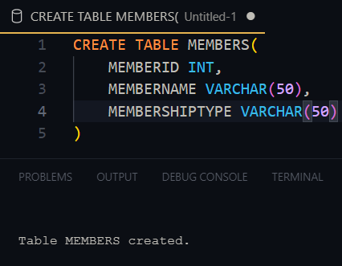

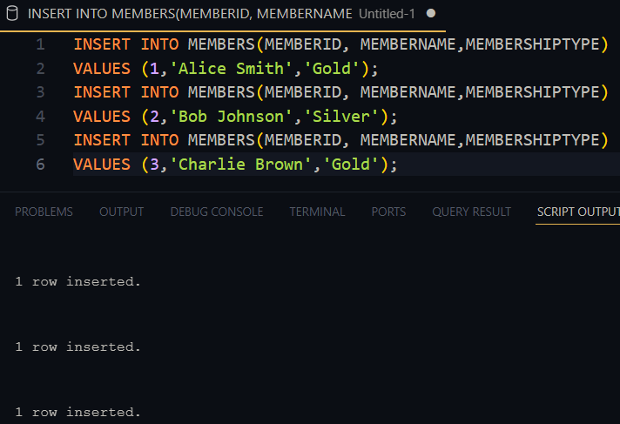

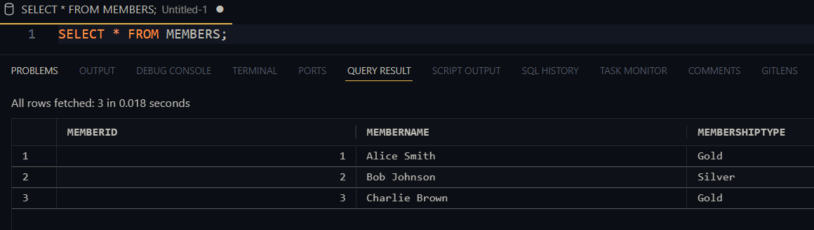

RESERVATIONS TABLE

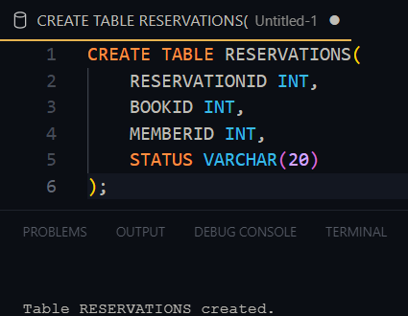

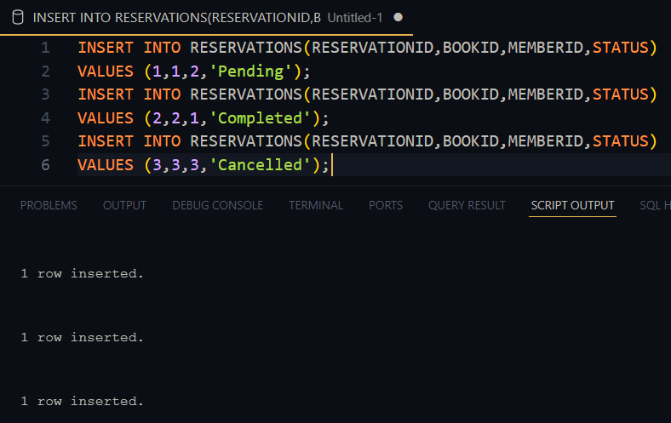

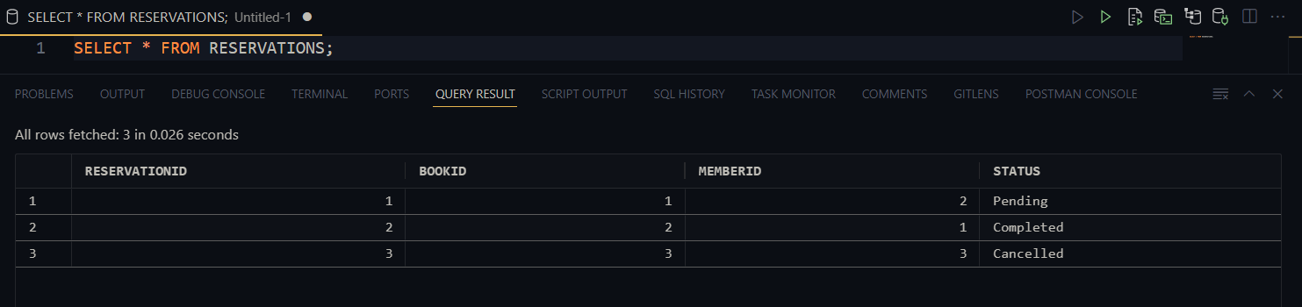

Qn1, Get the details of loans for members with 'Gold' membership.

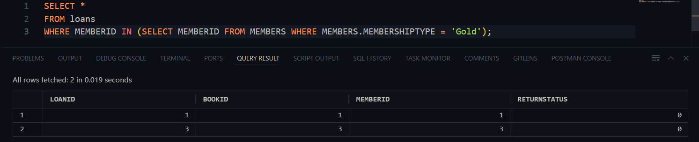

Qn2, Find all members who have a reservation for a book that is currently available.

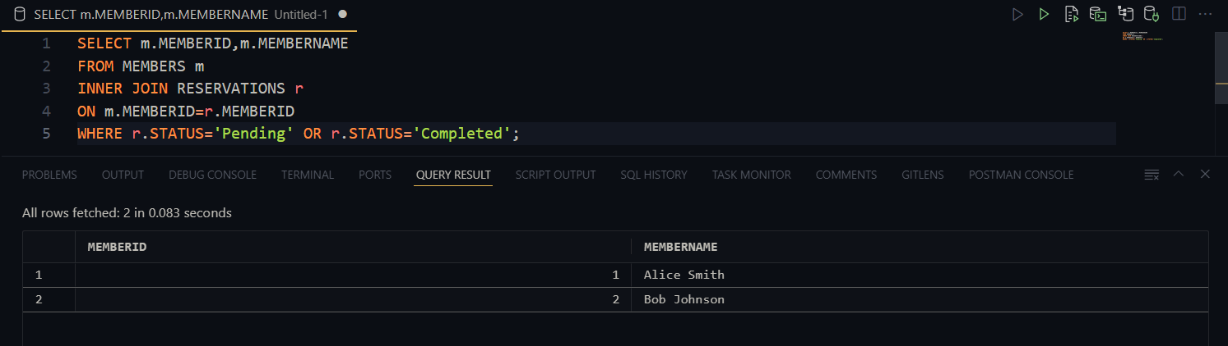

Qn3, Find books that have been loaned by 'Gold' members

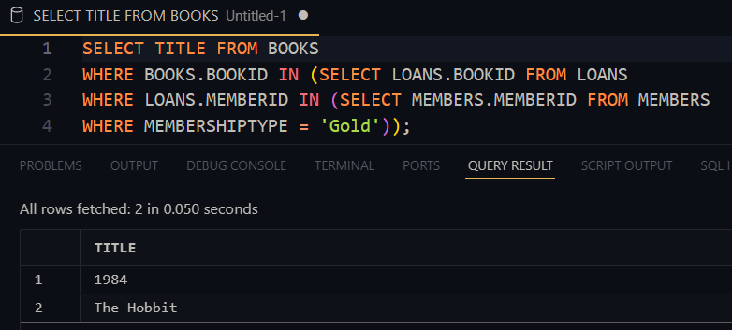

Qn4, Retrieve the members who have borrowed books that were also reserved by other members.

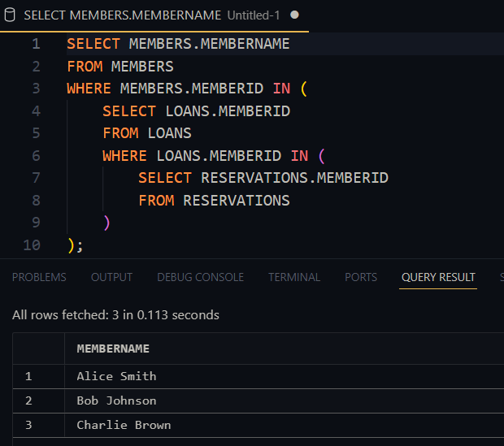

Qn 5, Show books that have been both reserved and loaned

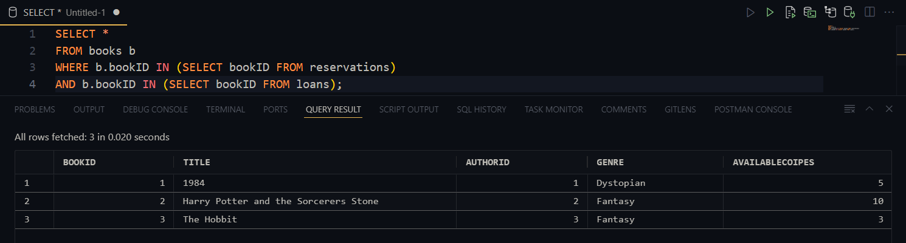

Qn 6, Find the total number of books that are available and have not been reserved

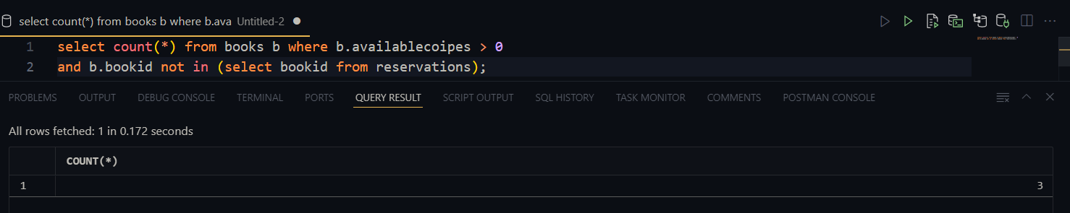

VIEWS

bookreservationstatus view

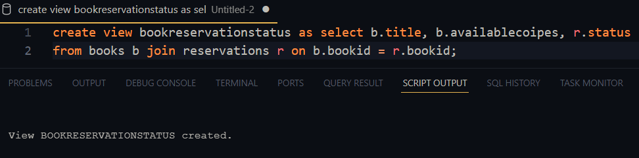

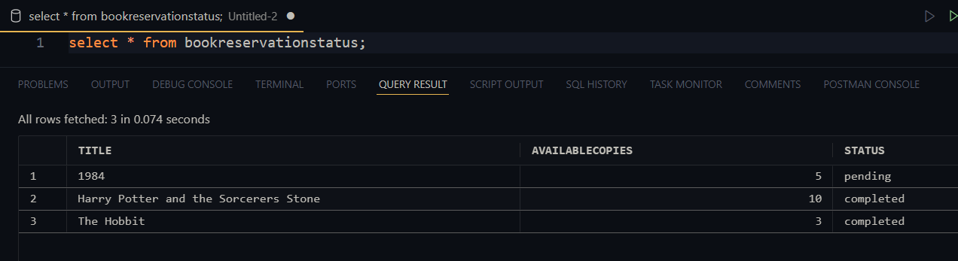

memberloanreservationcount view

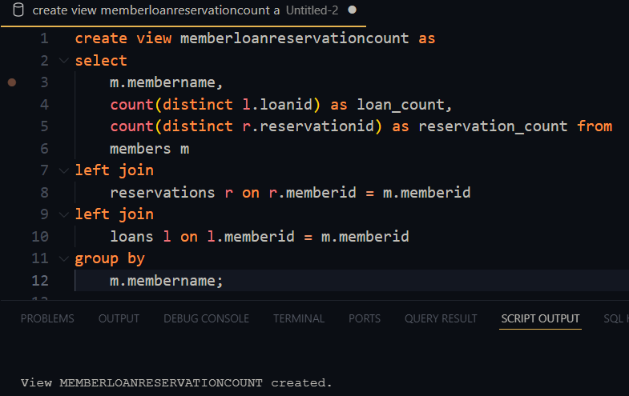

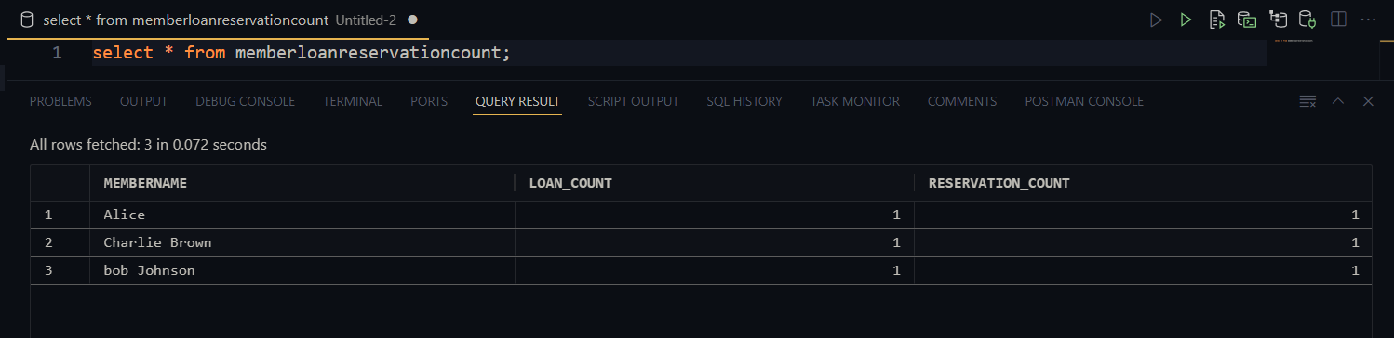

Authorbookcount view

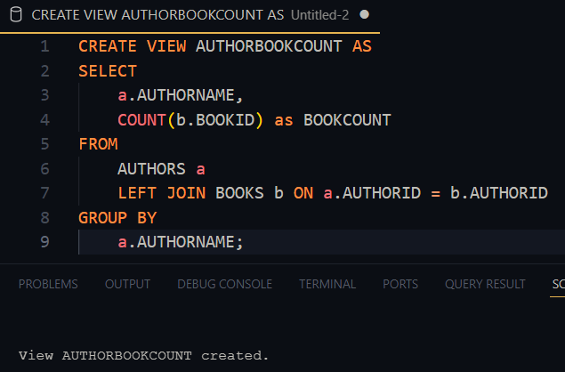

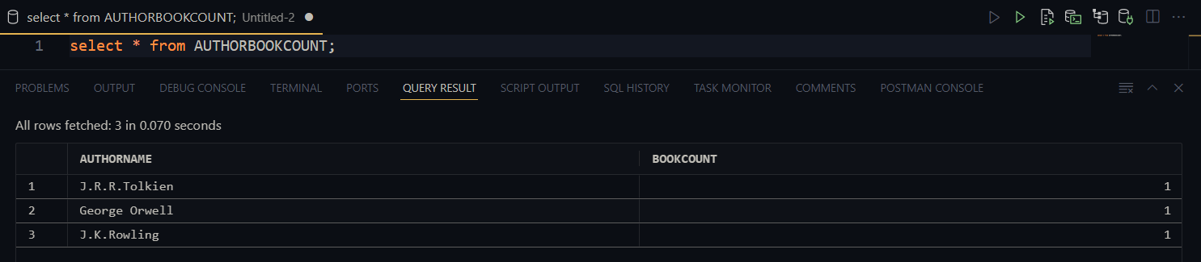

Qn 7,

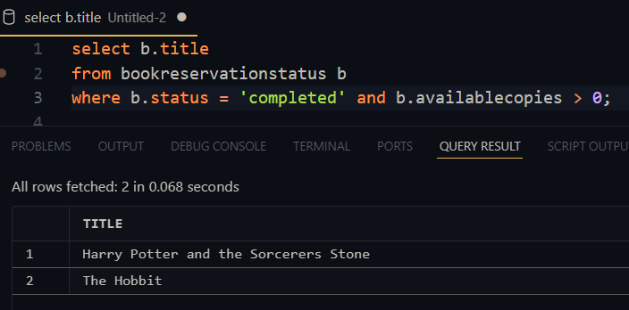

Qn 8,

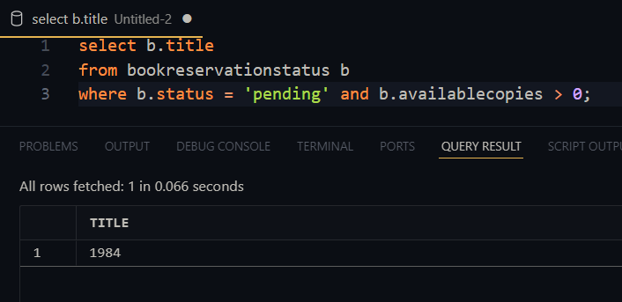

Qn 9,

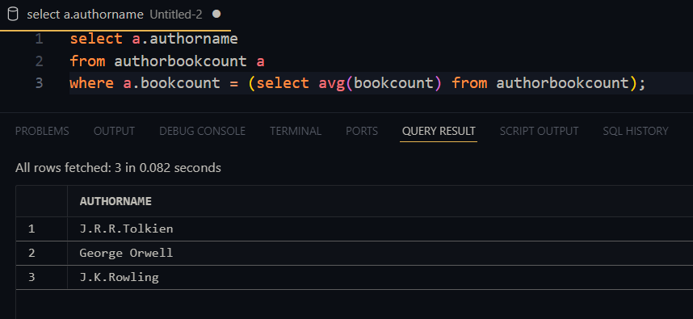

Qn 10,

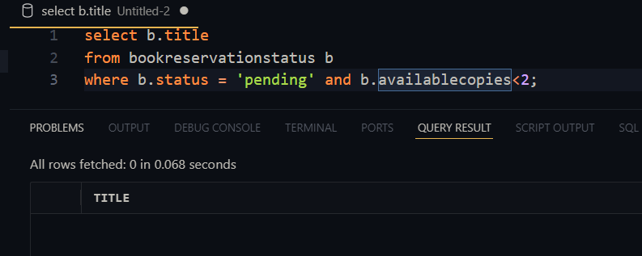

SCENARIO 4

APPOINTMENTS TABLE

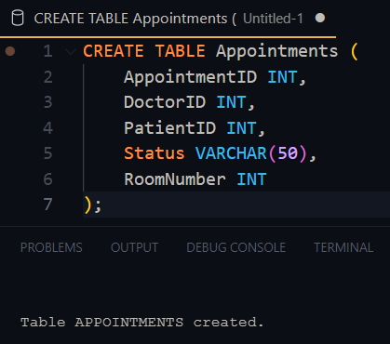

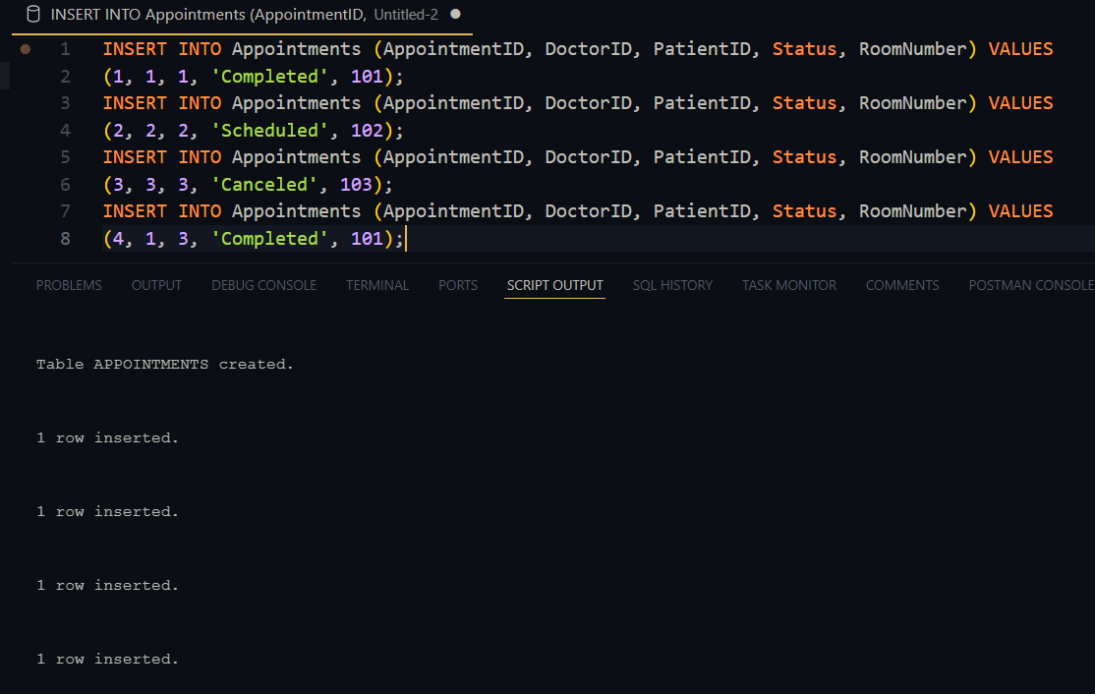

DEPARTMENTS TABLE

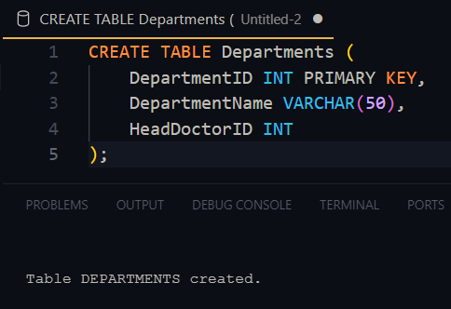

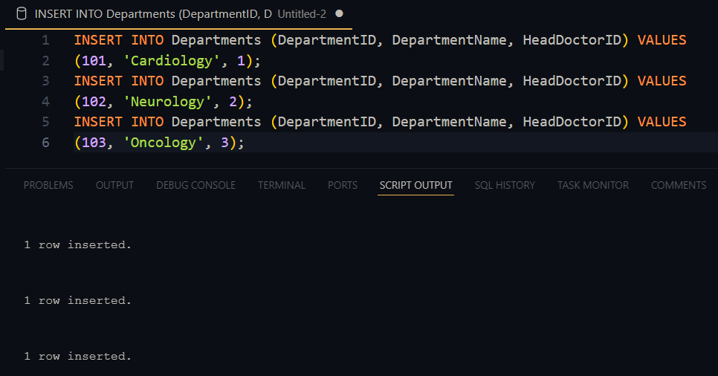

DOCTORS TABLE

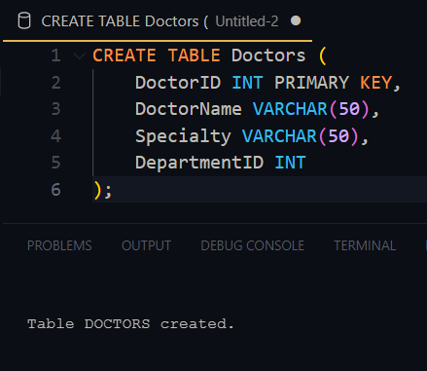

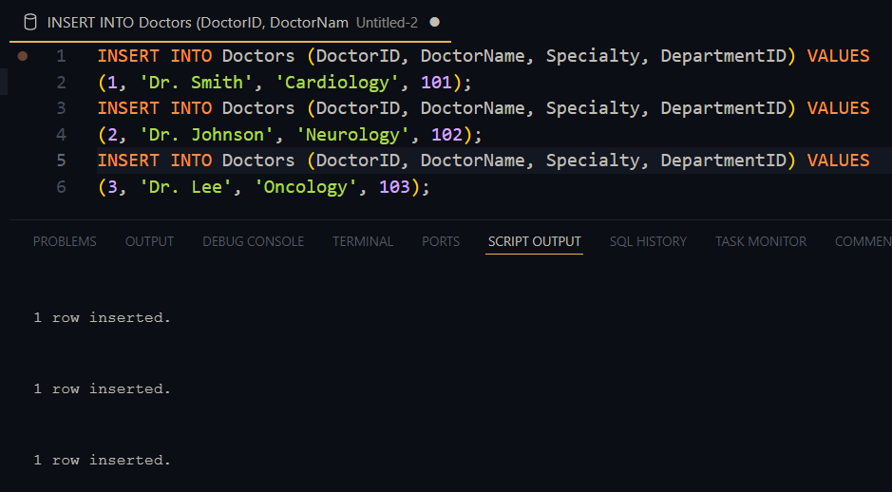

PATIENTS TABLE

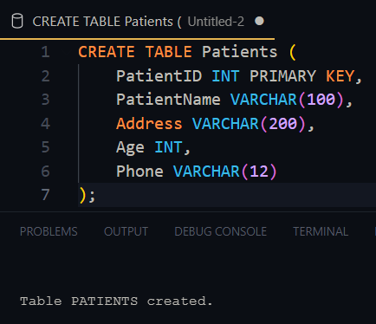

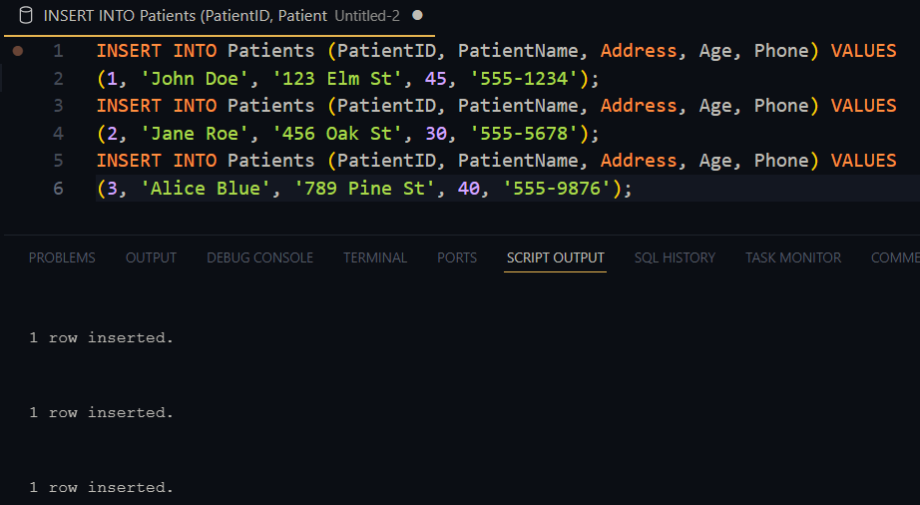

Qn1,

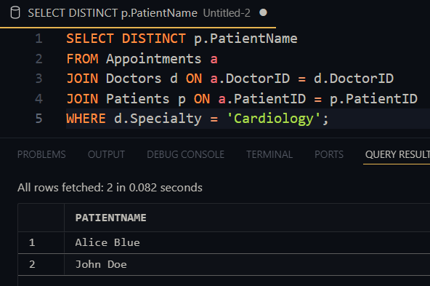

Qn 2,

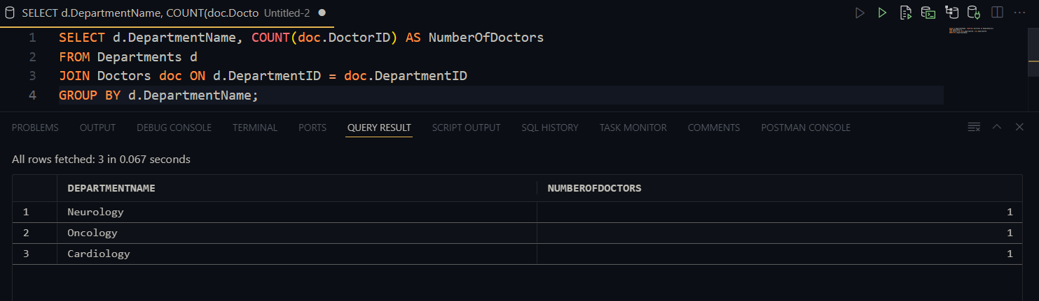

Qn 3,

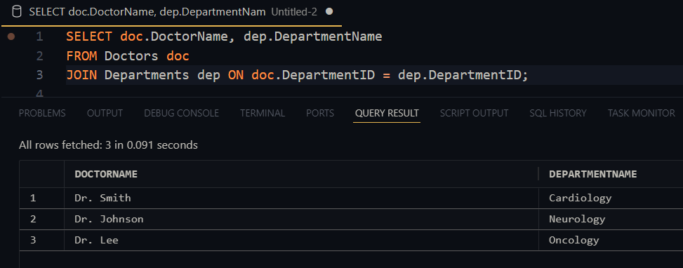Qn 4,

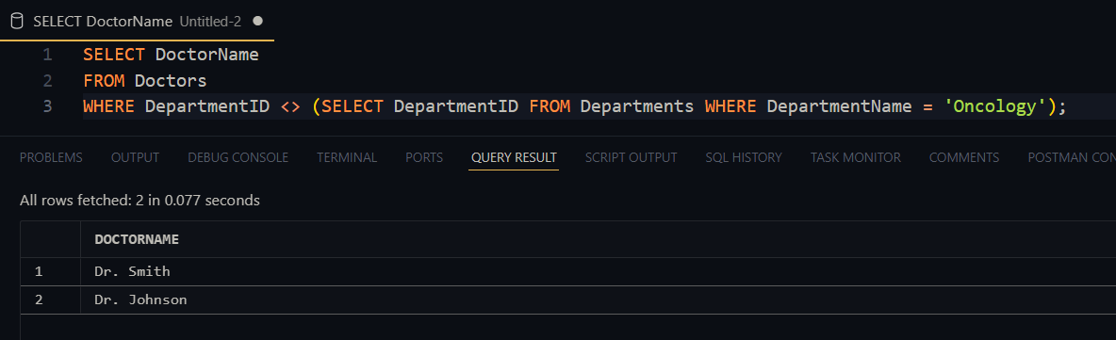

Qn 5,

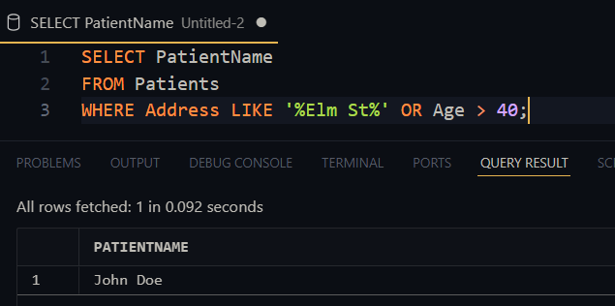

Qn 6,

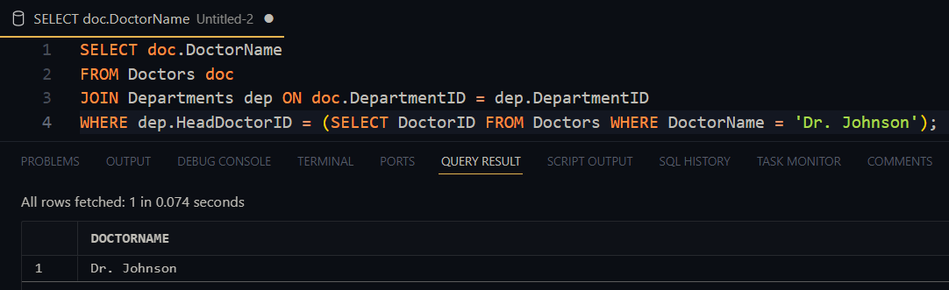

VIEWS

SCHEDULEDAPPOINTMENTSVIEW  
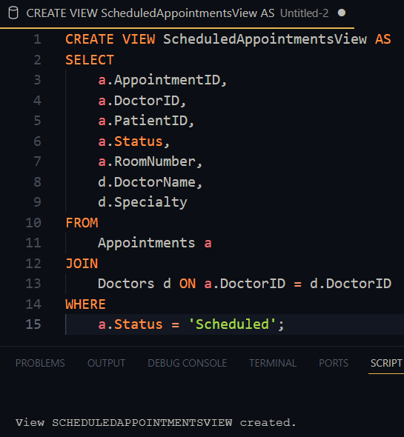

CompletedAppointmentsView  
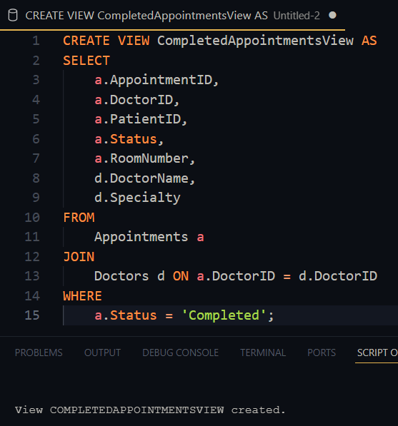

DoctorAppointmentCountView  
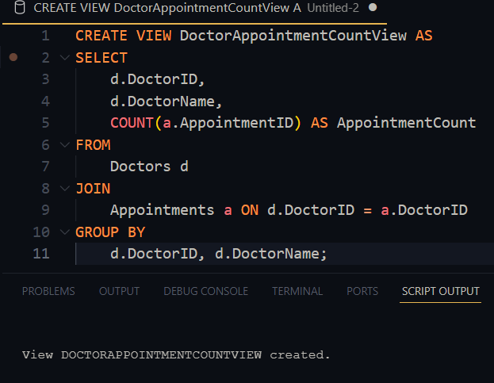

Qn 7,

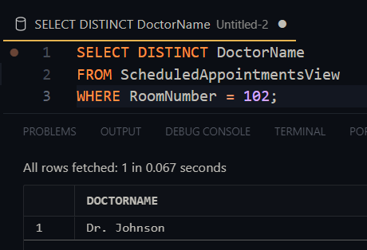

Qn 8,

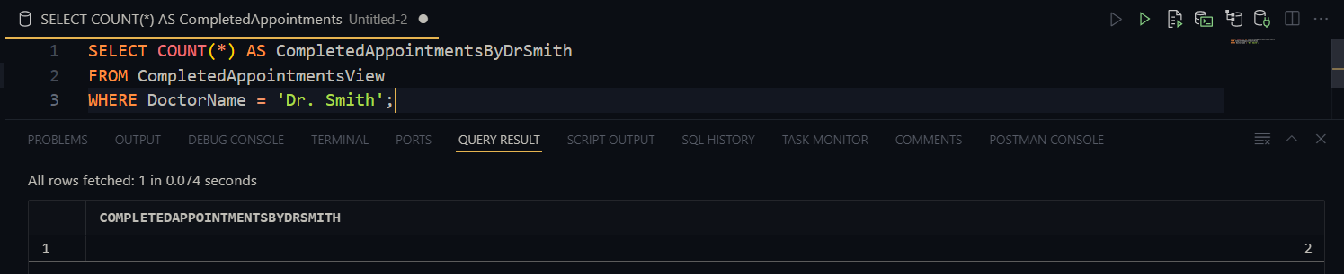

Qn 9,

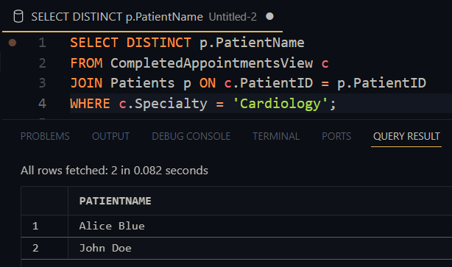

Qn 10,

